# **CTF Challenge: Scanning Website - Using Metascan Online**

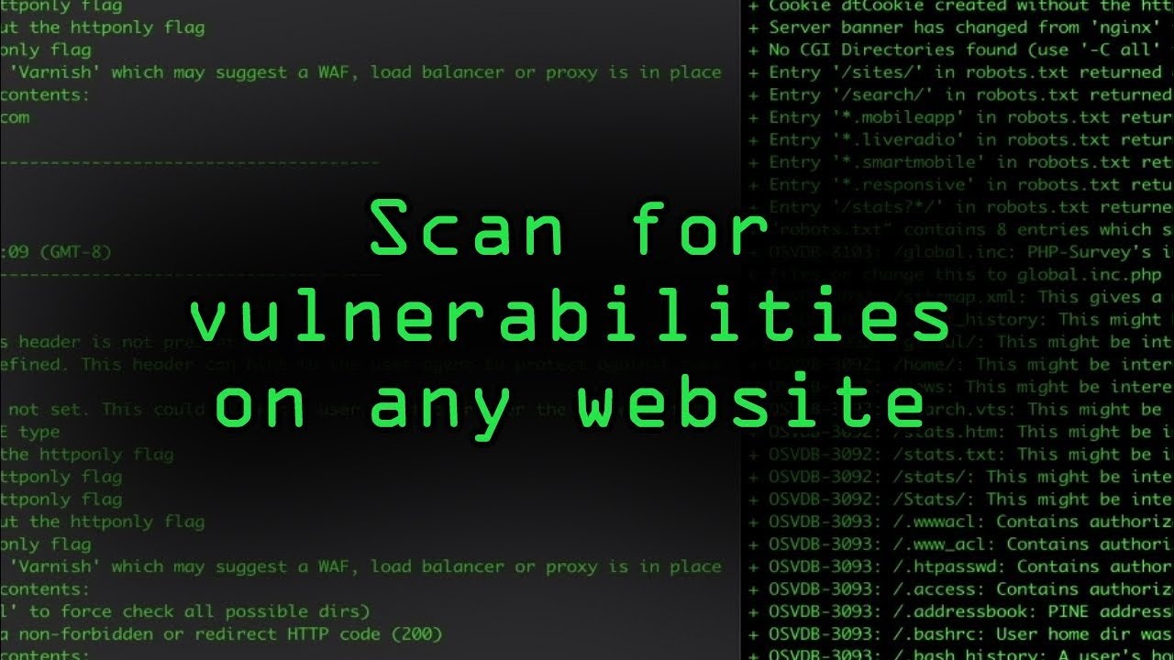

# **1. Introduction**

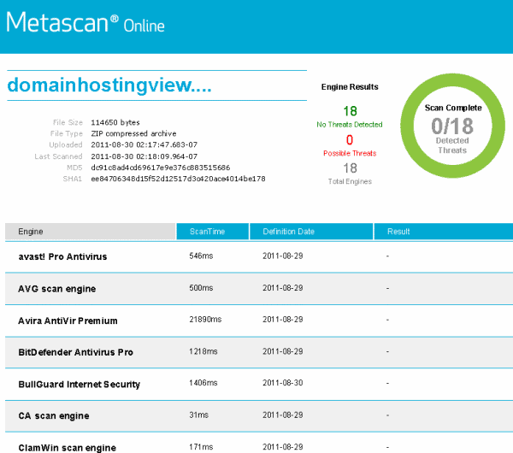

Metascan Online, now known as OPSWAT MetaDefender, collects and analyzes threat intelligence data to help you understand and respond to internet threats. This challenge will introduce you to Metascan Online to gather information about a specific IP address.

# **2. Tools and Requirements**

Access to the internet and (OPSWAT MetaDefender)

# **3. Scenario**



You are an ethical hacker tasked with gathering information about a specific Website using Metascan Online. Your job is to determine if the Website has been flagged for any malicious activity and identify one recent activity associated with it.

# **4. Process to follow while performing CTF**

Step 1: Visit Metascan Online (OPSWAT MetaDefender):

[**https://metadefender.opswat.com/**](https://metadefender.opswat.com/)

Step 2: Enter the Website Url: [**www.tiktok.com**](http://www.tiktok.com) in the search bar and start the search.

Step 3: Solve the CTF.

# **5. Let’s Begin the Challenge**

**Question**

**Flag 1: Is the Website flagged for malicious activity or not?**

*Answer: No*

**Flag 2: What is the Tags of the Given Website?**

Answer: Social Networking

**Hint**

